**KAMPALA PRIVATE TEACHER’S EXAMINATIONS SERIVCES**

***TEL: +25675120144/+256700666538/+256781928207***

**MID TERM I EXAMINATION 2024**

**PRIMARY ONE**

**LITERACY 1B**

**My name is ___________________________________________**

**I am in ________________________________________________**

**My school is _________________________________________**

1. **Fill in the missing letters.**

c ____t du ___k p ___ g

1. **Name these domestic animals.**

|  |  |  |
| --- | --- | --- |
|  |  | C:\Users\SEC COM 2 B\Desktop\download (2).png |
|  |  |  |

**(cow, dog, elephant, cat)**

1. A _________________________ is a place where we go to learn.

(church, school)

1. **Circle wild animals.**

goat, lion, dog, elephant, zebra

1. **Draw these found around us.**

|  |  |  |
| --- | --- | --- |
|  |  |  |
| **plants** | **hills** | **animals** |

1. **Match correctly.**



chalkboard



book

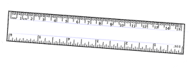

table

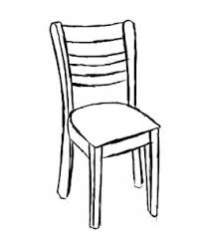

ruler

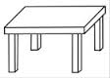

chair

1. _______________________ animals are the animals kept at home. (wild, domestic)
2. List down any two things found in class.

i) _____________________________________________________

ii) _____________________________________________________

1. **Draw these things we use to clean our school.**

|  |  |  |
| --- | --- | --- |
|  |  |  |
| **broom** | **rag** | **water** |

1. Name any two animals that God created.

i) _______________________

ii) _______________________

1. Give any two people found at school.
2. _____________________________________________________
3. _____________________________________________________
4. **Draw these activities done at school.**

|  |  |
| --- | --- |
|  |  |
| **skipping** | **dancing** |

1. **Match these activities done at home.**



cooking

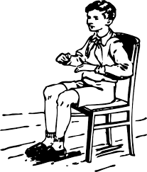

washing

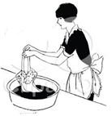

sweeping

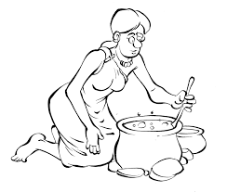

sitting

1. Name any two things you see on your way to school.
2. ______________________________________________________
3. ______________________________________________________
4. **Draw these wild animals.**

|  |  |  |
| --- | --- | --- |
|  |  |  |
| **lion** | **snake** | **elephant** |

1. Name these things we use at school.



_________________ ______________________

1. What is your name?

____________________________________________________________

**Good Luck**